* File Upload

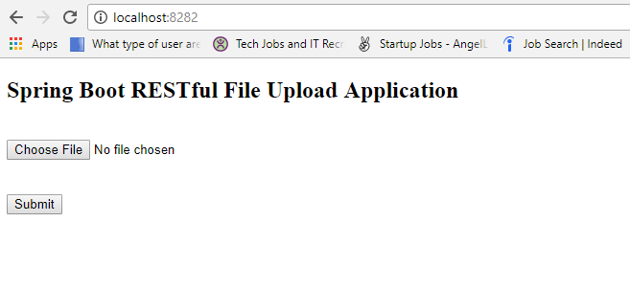

* File Upload – Select file  
    
  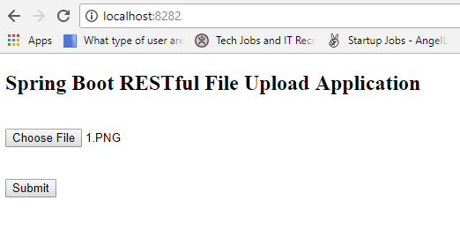
* File Upload – Status  
    
  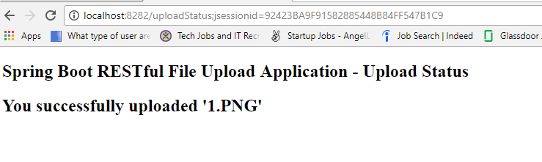
* File Upload – Folder structure  
    
  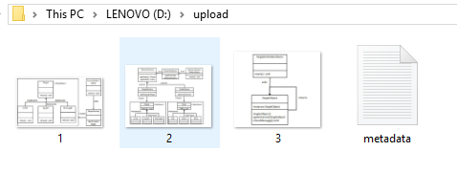
* Metadata.txt  
    
  